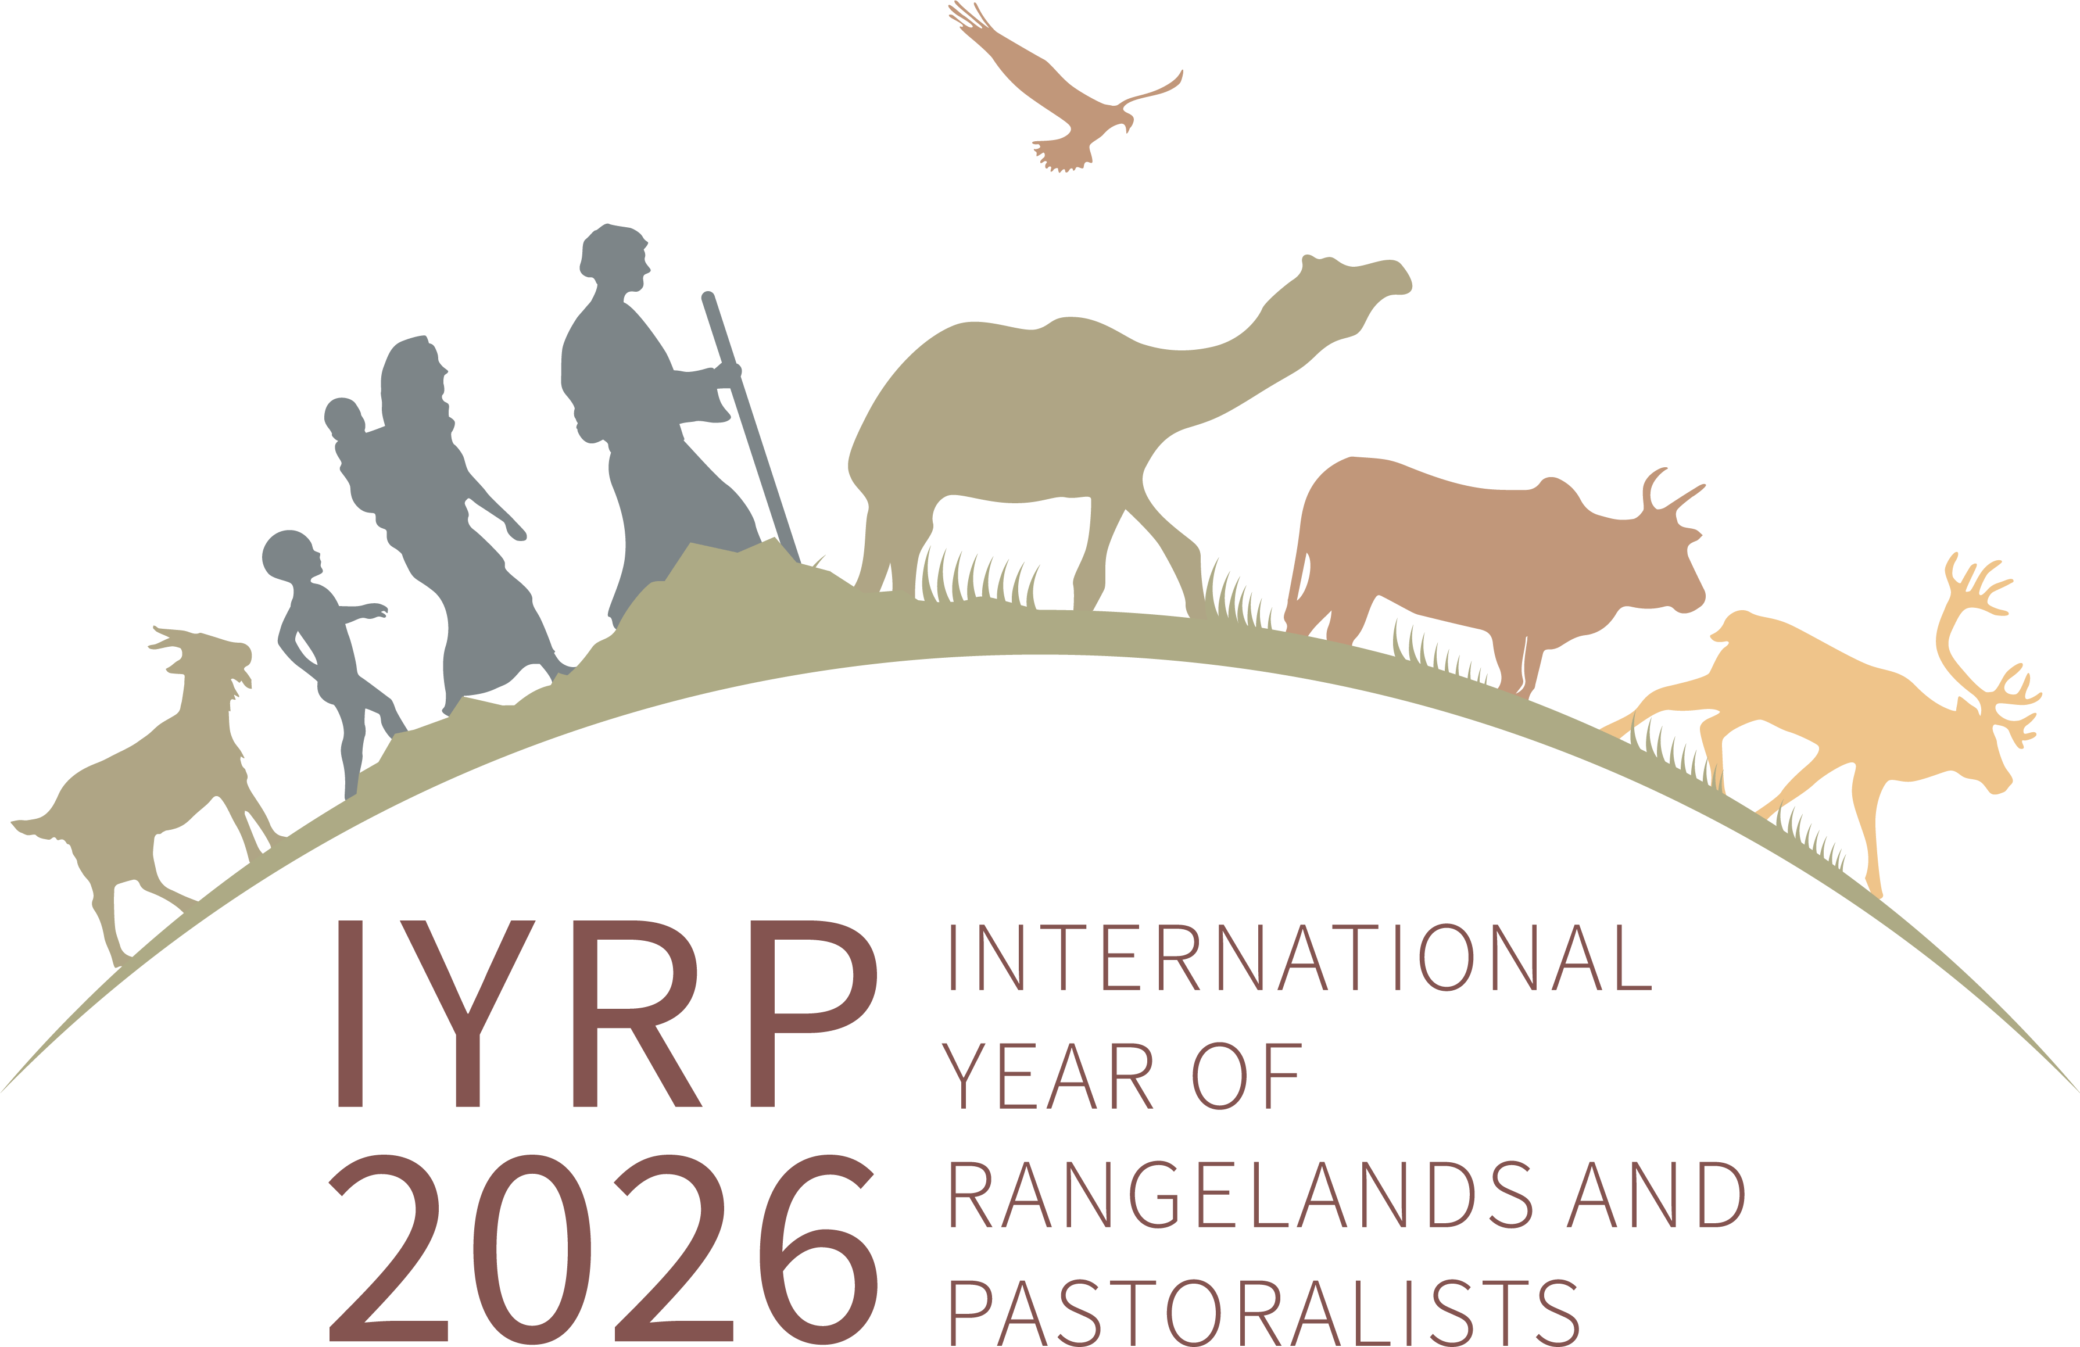

**International Year of Rangelands & Pastoralists (IYRP):   
information for pastoralist organisations**

*In March 2022, the United Nations (UN) declared 2026 as the International Year of Rangelands and Pastoralists (IYRP). This was originally proposed to the UN by the Government of Mongolia – traditionally a country of pastoralists – and was supported by over 100 countries and almost 300 organisations worldwide. The UN has asked its Food and Agriculture Organization (FAO) to implement the IYRP in 2026 to promote rangelands and pastoralists through awareness-raising and other activities. In the meantime, the alliance of numerous people and organisations that supported the Government of Mongolia’s campaign for the IYRP is engaged in several activities to prepare for it. These include making pastoralists and their organisations aware of opportunities to make themselves heard worldwide and to drive an agenda for recognition and support of pastoralism as the best way to use the world’s rangelands in a nature-positive way.*

***Why was an IYRP proposed?***

In its proposal to the UN, the Government of Mongolia argued that over half of the Earth’s land surface consists of rangelands: areas where the vegetation is made up of natural grasses and shrubs that are grazed by livestock and wildlife. The productivity and environmental health of rangelands are critical for the livelihoods and cultures of more than 500 million pastoralists (see box “To make things clear”). Billions more non-pastoralists benefit from these areas through animal products, tourism, wildlife and biodiversity conservation, renewable energy and other services.

The Government of Mongolia proposed an IYRP so that more people in the world – especially policymakers – would recognise the great value of rangelands and pastoralists and gain a better understanding of how these contribute to the economy, environment, society and culture at national and global level. An IYRP would raise awareness of the challenges and opportunities of life in the rangelands, including the need for access to mobile health and education services, access to production inputs and markets, security of resource-use rights, conflict resolution and investment in improving the rangelands. The IYRP would call attention to the need for better policies in and between countries worldwide to favour pastoral production systems.

### To make things clear

### “*Pastoralists*” are people who – as their primary source of living – raise livestock, wild or semi-domesticated animals on plants that grow naturally, often on areas called rangelands and grasslands.

### A “*pastoralist organisation*” is a group of pastoralists who act together to improve the lives of the members, for example, by facilitating their access to information and markets and by advocating for pastoralists’ rights. The organisation may be registered (formal) or not (informal).

### A “*pastoralist support organisation*” is a nongovernmental or governmental group of people who support pastoralists in their development and advocacy, but most of them do not practise pastoralism themselves.

***Why is an IYRP important for pastoralists?***

* It will increase respect for the achievements of pastoralists around the world – men and women – in producing food and other products in harsh and challenging environments such as dry, mountainous and remote areas.
* It will strengthen pastoralist organisations and networks (local, national and international) and make them more visible by providing a global platform i) to advocate for their rights to development programmes and laws that meet their needs and ii) to exchange their knowledge and good practices.
* It will showcase pastoralists’ pride in their work and culture, also among young people, and reinforce their traditions and diversity, thus supporting their quest for greater recognition of their way of life.
* By making pastoralists more widely known and valued, it will enhance opportunities for them – including women and youth – to generate additional income through new products and markets.
* It will give the impetus and means for pastoralists and scientists to carry out joint research to generate good data about the situation of pastoralists and rangelands. This information will be useful for pastoralists in managing land and water and in lobbying for their rights.
* It will improve collaboration between pastoralists and scientists to help pastoralists innovate and adapt to change so that their wellbeing is ensured.
* It will help integrate pastoralists’ concerns into national and regional planning and stimulate development of better policies that allow pastoralists to make the best possible use of the rangelands and other areas on a seasonal basis by moving their livestock and peacefully negotiating access to grazing and water and to secure livestock routes. This should help reduce conflicts with cropping, national parks, wildlife preserves, privatised grazing areas, tourism and companies e.g. for mining, oil extraction or alternative energy sources.
* It will reinforce and expand efforts to set up services for appropriate animal and human healthcare and education for mobile pastoralist families.

***Who is and can be involved in the IYRP?***

The Government of Mongolia drew up its proposal in partnership with national and international organisations, including government bodies, in several countries. It has formed a National Support Group (NSG) with people from civil society organisations and the Ministries for Agriculture, Environment & Tourism, and Foreign Affairs to coordinate the preparation for and implementation of the IYRP in Mongolia. An International Support Group (ISG) with now almost 500 members from around the world is working closely with the NSG, primarily through a Global Coordination Group (GCG) of 48 people. One third of the ISG members are with pastoralist and pastoralist-support organisations, including the World Alliance of Mobile Indigenous Peoples and Pastoralists (WAMIP). Other members are from international organisations, government agencies, universities, research institutes and nature-conservation groups. The FAO Pastoralist Knowledge Hub (PKH), which helps pastoralists advocate for sustainable rangeland use and pastoralist-friendly policies, supports the IYRP campaign through its communication channels and events.

***How can pastoralist organisations become involved?***

National governments and various types of organisations, including pastoralist and pastoralist-support organisations, have sent letters of support to the Mongolian proposal for an IYRP. All organisations that express support for the IYRP become members of the ISG and are included on the website as [Friends of IYRP](https://www.iyrp.info/friends-of-iyrp). More letters of support from pastoralist organisations are welcome! Please send your logo.

The ISG set up a website ([www.iyrp.info](http://www.iyrp.info)) initially to inform representatives of national governments involved in the UN and later for the general public. The website brings news about IYRP-related activities. It is also meant to give voice to pastoralists worldwide. It includes short videos and photos of pastoralists and rangelands. The website offers a window to the diverse worlds of pastoralists and rangelands. Further films, photos and logos are welcome!

Eleven Regional IYRP Support Groups (RISGs) have formed to plan and implement activities in their respective region in the time leading up to and during the IYRP. All organisations wanting to actively promote pastoralists and rangelands in their region are welcome to join the relevant RISG. Pastoralist and pastoralist-support organisations are particularly welcome so that they can play a key role in shaping the IYRP. The RISGs meet virtually as well as at international conferences about rangelands and pastoralism. More regional and global meetings of IYRP supporters are foreseen, including at the International Rangeland Conference (IRC) to be held in Australia in 2025.

Several thematic Working Groups (WGs) are open to anyone interested in collaborating with other ISG members on the themes, e.g. afforestation in rangelands, biodiversity, climate change, gender, land, pastoral economics, water and youth. For contacts of the WG facilitators, see the [Working Group Update](https://www.iyrp.info/sites/iyrp.org/files/IYRP%20Working%20Group%20Updates%20October%20%202024.pdf).

***Examples of activities foreseen up to and during 2026***

Some examples of activities that will be carried out in the years up to and including the IYRP 2026 are:

* National-level events, including showcasing sustainable pastoral systems, awards and prizes, innovation fairs, video documentaries, a World Herder Day and educational materials
* Social media campaigns and video productions to raise awareness of producers, consumers and policymakers worldwide
* Pastoralist gatherings – including gatherings of women pastoralists – at national, regional and global level to share knowledge and develop joint plans to improve the lives of pastoralists
* Joint research by pastoralists and scientists to fill in gaps in documented knowledge and information about pastoralists and rangelands at national and regional level
* An international conference on pastoralists, rangelands and the Sustainable Development Goals (SDGs), bringing together environmental, social and economic aspects in an integrated vision.

The IYRP could focus each month on a particular theme, as shown below. This is a suggestion that can still be discussed and improved by pastoralist and other organisations united in the IYRP 2026 alliance.

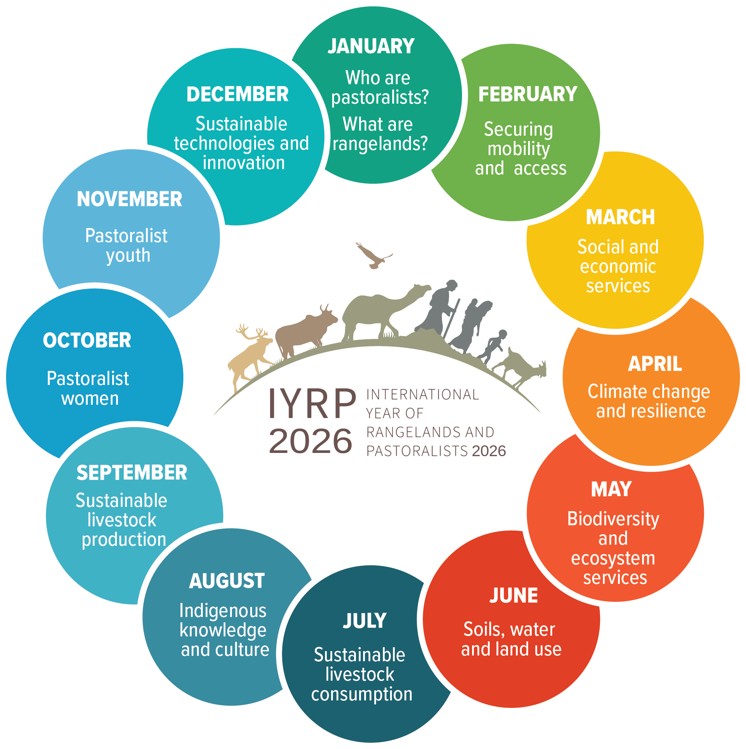

***Possible monthly themes during IYRP 2026***

For more information, please see:

<https:///www.iyrp.info> and

<https://rangelandsgateway.org/international-year-rangelands-and-pastoralists-initiative>

or contact [iyrp2026@gmail.com](mailto:iyrp2026@gmail.com)